Assessment and reporting within an A-E framework

Processes for quality
assessment in HPE

Scan QR code to access all resources from today’s workshop or go to:

https://janiceatkin.com/assessment-workshop-wollongong/

Workshop agenda

8.45 | Registration - Tea/coffee
9.00 | Session 1: Setting the scene  Introduction and overview  - Why are we here?  - Why do we assess/report?  What’s happening at your school?  - What are the challenges?
9.30 | Session 2: Planning processes  What do we want students to learn?  - Identifying learning intentions and expectations  - How and why does that learning matter?
10.45 | Morning tea
11.00 | Session 3: Planning processes (continued)  What and how do we currently assess?  - Assessment tools  - Considerations when selecting assessment tools  - Exploring alternative assessment methods  What do we need to record?  - Collecting evidence of learning  - Collating evidence of achievement  - Making consistent judgements about student achievement
12.45 | Lunch
1.15 | Session 4: Planning processes (continued)  What do we want to report?  - Understanding the A-E rating scale  - What does “typical” student achievement look like?  - Exploring levels of achievement
3.00 | Session 5: Planning future directions
3.30 | Reflection, evaluation and close

Workshop outcomes

As a result of participating in this workshop, participants will have an improved understanding of:

- the processes that can be used to plan effective teaching, assessment and reporting from the DRAFT PDHPE K-10 syllabus.
- the DRAFT PDHPE outcomes and content for Stage 4, to support effective teaching, assessing and reporting planning
- practical school-based strategies for quality assessment and reporting processes in PDHPE.

Professional Teaching Standards addressed:

- 5.1 Develop, select and use informal and formal, diagnostic, formative and summative assessment strategies to assess student learning.
- 5.3 Understand and participate in assessment moderation activities to support consistent and comparable judgements of student learning.
- 5.5 Report clearly, accurately and respectfully to students and parents/carers about student achievement, making use of accurate and reliable records.
- 6.2 Participate in learning to update knowledge and practice, targeted to professional needs and school and/or system priorities.
- 6.3 Contribute to collegial discussions and apply constructive feedback from colleagues to improve professional knowledge and practice.

Assessment reflection sheet

How do you currently assess your students?

What is working well?

How do you collect and collate evidence of student achievement?

What assessment strategies do you use currently?

How confident are you that report grades accurately reflect achievement?

Session 1:

Setting the scene

Workshop reflections ……. (https://padlet.com/janice9/5e6plifpao14)

Current challenges |  | Possible solutions
 | Thoughts | Insights | Questions
Session 1
Session 2
Session 3
Session 4

Session 2:

Planning processes
What do you want students to learn?

Unpacking the learning intentions and expectations

Understanding and Skills | Outcomes | Content | Learning expectation

Session 3a:

Planning processes

What and how do we assess?

Workshop activity:
Build a picture of what learning is valued in your assessment

Reflection questions

Are there opportunities to teach and assess multiple understandings or skills simultaneously? How?/When?

Do your learning intentions prioritise some understandings and skills over others? If so, which ones? What messages does this give your students?
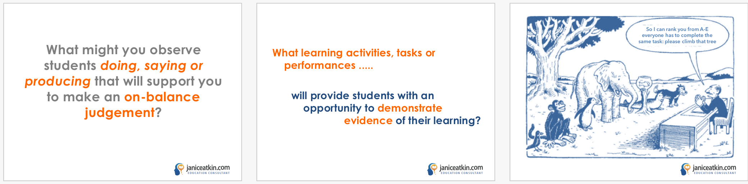

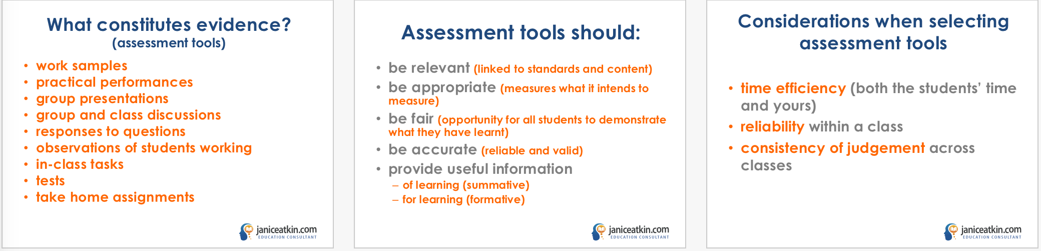

Workshop activity

Select a unit of work from your program

Consider the following question to reflect on the assessment opportunities in your unit of work

- Highlight which learning activities could provide an opportunity for students to demonstrate their understanding and skills.

- What might students do, say or produce that demonstrate they have learnt what you intended?

- Select a lesson sequence and identify what it is you want students to understand and be able to do by the end of the lesson.

Session 3b:

Planning processes

What do we record?

Workshop activity

Select a unit of work from your program

Consider the following questions to plan for more efficient and valid assessment opportunities in your unit of work

- What evidence can you observe and collect about student learning?

- How can you record evidence of student learning in an efficient and valid way?
Add descriptions of evidence of learning into blank recording template

- How well do you expect them to demonstrate their learning?
Design a key for recording your observations

Develop an observation record for your selected unit of wor

Observational assessment recording blank template

Unit name: |  |  |  |  |  |  |  | Year:
Class: | Evidence of learning to be demonstrated |  |  |  |  |  | Additional evidence: Comments and annotations
Teacher:

Example keys:

Level of …..
1.
2.
3.

Level of …….
A.
B.
C.

Names

Session 4:

Planning processes

What do we report?

A – E scale: What does it look like in your context?

NSW A-E descriptors

A – Outstanding Achievement: The student has an extensive knowledge and understanding of the content and can readily apply this knowledge. In addition, the student has achieved a very high level of competence in the processes and skills and can apply these skills to new situations.

B – High Achievement: The student has a thorough knowledge and understanding of the content and a high level of competence in the processes and skills. In addition, the student is able to apply this knowledge and these skills to most situations.

C – Sound Achievement: The student has a sound knowledge and understanding of the main areas of content and has achieved an adequate level of competence in the processes and skills.

D – Basic Achievement: The student has a basic knowledge and understanding of the content and has achieved a limited level of competence in the processes and skills

E – Limited Achievement: The student has an elementary knowledge and understanding in few areas of the content and has achieved very limited competence in some of the processes and skills

ACTIVITY: HIGHLIGHT the difference between each level of achievement above.

Exploring levels of achievement

ACARA work samples
http://www.australiancurriculum.edu.au/health-and-physical-education/curriculum/f-10?layout=1

Queensland standard elaborations
https://www.qcaa.qld.edu.au/p-10/aciq/standards-elaborations/p-10-hpe

Interpreting achievement - understandings

Limited level | Sound level | High level

Planning your next steps

Areas for action | This week | This term | This year
teaching and learning

assessment processes

professional development

reporting processes

3-2-1 reflector

3 people you will have a conversation with when you get back to school

2 insights you will share with each of these people

1 question that you still have and need to investigate further

Scan this QR code to access the workshop evaluation or go to:
https://ja53.typeform.com/to/ITpWOW

